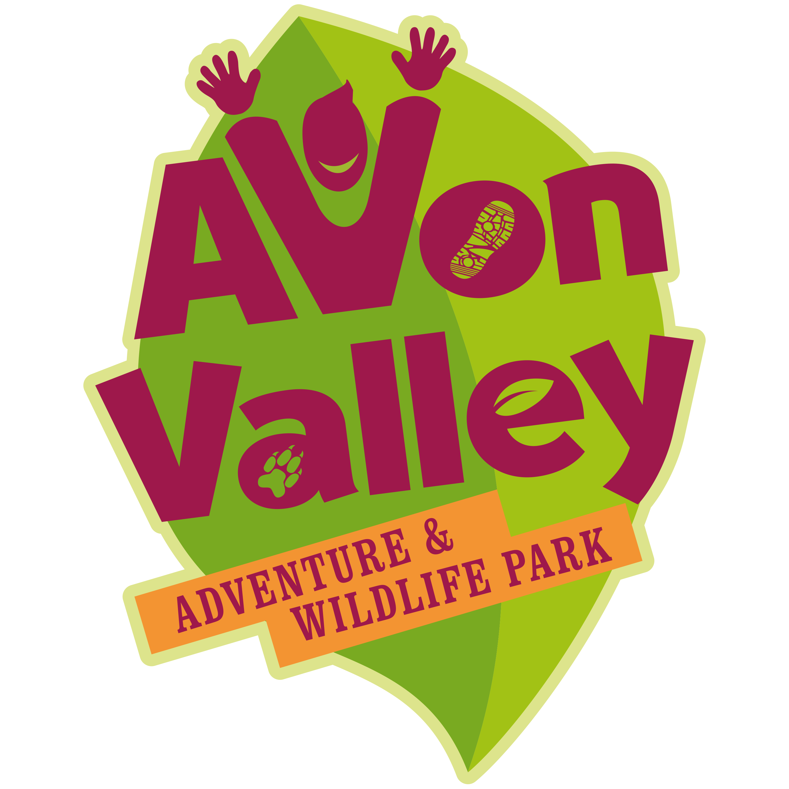

GROUP VISIT BOOKING FORM – 2017 – DURING PUBLIC OPENING
Groups are classed as a non-educational visit of 20 or more paying visitors to the Park.
We offer 10% off the day admission for groups.
For further information call 0117 986 4929 or email info@avonvalley.co.uk

NAME OF GROUP:

CONTACT NAME:

TEL. NO:

EMAIL:

ADDRESS:

DATE OF VISIT: TIME: FROM TO

TOTAL NUMBER VISITING:

ADULTS CHILDREN (2-16YRS) TODDLERS (<2YRS)

ANY OTHER INFO

DOES ANY MEMBER OF YOUR GROUP HAVE ADDITIONAL REQUIREMENTS THAT WE SHOULD BE AWARE OF? (E.G. DIFFICULTY WITH WALKING, LEARNING DIFFICULTIES, ASTHMA ETC.)

IMPORTANT – PLEASE NOTE THE FOLLOWING:-
1. Whilst every effort is made to ensure that our park is as safe as possible, adequate child supervision must be provided by the group itself. We require a minimum of 1 adult per 6 children. Extra cover is always preferable. Supervisors must be 18 years of age or over.
2. Children and leaders must wear an identification to show which group they belong to
(This can be as simple as a self-adhesive label with the group’s name written on it).
3. During their visit leaders must remain with their own group of children in all areas of the park at all times, and supervise them accordingly.
4. Avon Valley will evict any child from the park if he or she is found to be behaving badly. It is therefore important for group leaders to have both personal and transport available if it necessary to take a child home during the day, and that there are adequate remaining adults still available to supervise.
5. Avon Valley is not able to accept responsibility for accidents to visitors or damage or loss of personal possessions caused during the visit.

I have read the information above and confirm that I wish to make a booking on the terms detailed above.

Signed*: Name:
On behalf of:

* by electronically signing this signature and emailing the form in you agree to these terms and conditions.

PLEASE RETURN THIS FORM COMPLETED TO info@avonvalley.co.uk you will then receive a quote for the proposed visit to book with us.

