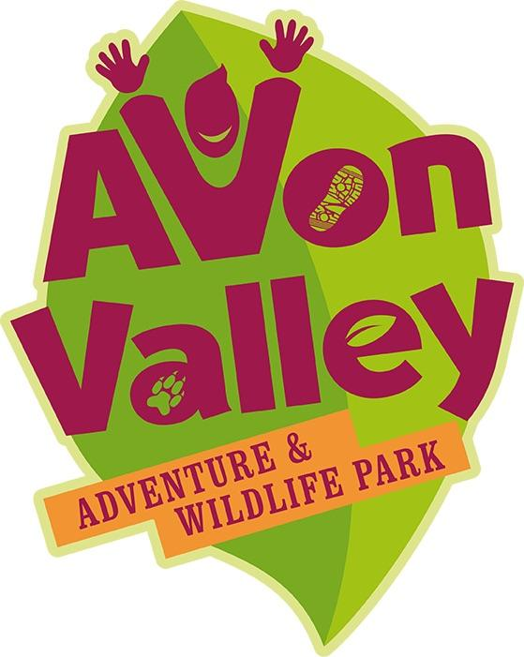

Welcome to Avon Valley Adventure and Wildlife Park’s Facilities and Accessibility information.

We hope the following information will help you navigate your visit to Avon Valley Adventure & Wildlife Park easily and help you have an enjoyable day out with us.

We understand that everyone has different needs so if you have any further enquiries please do get in touch if we can help you with any requirements you may have. You can contact us by email info@avonvalley.co.uk or by phone on 0117 986 4929.

Before you visit

Located between Bristol and Bath, Avon Valley Adventure and Wildlife Park offers an interactive, fun, learning adventure experience for everyone, whatever their age or ability.
If you are using a SatNav to find us, our post code is BS31 1TP, we recommend keeping your eyes open for the brown directional signage, as we are located at the end of Pixash Lane.
If you wish to visit using public transportation, we recommend using the 38/X39 Bristol-to-Bath service which stops at Snapdragons Nursery (Ellsbridge House) on the main Bath Road. There is then a short walk from the bus stop to our main Park, located at the end of Pixash Lane.
Please be careful when visiting us, as the local railway bridge is fairly steep and narrow, so whether on foot or in a car, please approach with caution.

The great British weather can be ever-changing, so we recommend bringing clothes suitable for all weathers. For sunny weather, we recommend hats, sunglasses and suncream. When it has been raining, wellington boots are suggested for grassier areas. We ask that all visitors wishing to use our indoor play barn cover their skin and wear socks, this is to reduce injuries and helps with hygiene.

Please know our busier periods are weekends, school holidays and our event days. Our indoor play barn can also be busier on wet weather days and after 3.30pm on a school day.

When you arrive

Parking

We have allocated disabled parking near our front entrance, we ask that you only park in these areas if you have a blue badge.
There is plenty of parking for all our other visitors. All of our car parking at Avon Valley Adventure and Wildlife Park is free of charge, unless stated (i.e. for special events).
Please be aware, our car park, and some areas within the Park are gravelled with stone and may be uneven in places.
The nearest toilets to our car park are inside the Park so please bare with us on entry as we do need to admit your party correctly before allowing you onto site.

During your visit

First Aid

The majority of our staff are first aid trained and are always happy to assist if you have an injury whilst visiting us. We do ask that any incident is reported to us. Please be patient with our staff whilst they deal with your injury, they will need to fill in an incident report form and take relevant information and details, including photographs. In line with data protection and GDPR, we keep this information secure and you can request this at any time.

Smoking

As a children’s Park, and for the health and well-being of our visitors, we are now a completely smoke-free and vape-free site. We ask that you respect this and if you wish to smoke or vape, you do so in our car park. We offer a free re-entry stamp so we know you have already accessed the Park earlier in your visit.
Please remember to dispose of your cigarette end in the sand bucket provided. This helps protect the environment.

Lost and Found

If a lost item is handed into a member of staff, we keep it in our designated ‘Lost and Found’ area for approximately six weeks. If you have lost an item whilst visiting Avon Valley Adventure and Wildlife Park, we ask that you give us a description of the item, your name and number so we can contact you if the item is found.
If you discover you have lost something after your visit, you can contact us on 0117 9864929 or email info@avonvalley.co.uk
Please remember that we cannot be responsible for your items on site, and anything brought into the Park is at your own risk.

Lost Children

We have over 90 acres of land at Avon Valley Adventure and Wildlife Park, so we suggest that you arrange a meeting point with your child if they lose their adult supervisor.
If your child is lost, inform a member of staff immediately. We have a lost child policy which we will implement immediately. Our staff will all be involved in finding your child, so please do bear with us if you visit when a child is lost. We will aim to find your child as soon as possible, and the duty manager will keep the adult reported informed throughout this. As part of our policy, we close our front entrance gate and may ask to check your car, please assist us by staying patient through this.

Maps

A site map is located near the entrance of Avon Valley Adventure and Wildlife Park, we suggest taking a photograph of this when you enter to help you navigate around the Park with ease. We can offer a paper-copy of this map on entry if you require one. Just ask a member of our team if you are not offered one.
If, throughout your day, you need any assistance though, just ask a member of staff who will be able to help you.

Cash Points

We have one cash point onsite which is run by NoteMachine. NoteMachine charges £1.50 per transaction.

Food and Beverage outlets

There is an onsite Café serving food, drinks and snacks from 10am until 5pm each day. In busier periods we also open additional food and beverage outlets across the site for your use.

Dietary Requirements

We cater for Gluten Free, Dairy Free, Vegetarian, Vegan and Allergies. Please ask a member of staff if you need assistance with your food choices.

Toilets

There is a main toilet block based near the Café/Play barn/Main entrance. This block has unisex toilets, a disabled toilet (please note that this toilet is not fully accessible), male urinals and baby changing facilities.

Baby areas

We have baby changing facilities available in our main toilet block. For hygiene reasons, we ask that you change your baby in these locations provided and dispose of your child’s nappy correctly.
We are a breast-feeding friendly attraction, but if you would like to breast-feed in private, we do have a small room available for you to do this.

Wheelchairs and Pushchairs

We have one wheelchair for hire which is available to all visitors on a first-come-first-served basis. We recommend bringing your own wheelchair or motorised scooter.
Whilst most of our surfaces across the site are flat, some areas are gravel which may be difficult for some wheelchairs and pushchairs. Our Riverside Trail (open Easter to Autumn) is accessible via a hill which some may struggle with.
Our indoor areas are level and ramped for ease.

Carer’s Policy

We allow one registered carer to accompany a disabled person free of charge into the Park. Proof of carer is required on entry, this can come in the form of a locally-issued carers emergency card, DLA letter or carer allowance letter. We prefer carers ID (or an emergency carers card) which you can apply for through your local carers centre - there’s lots of benefits to this card to assist you in your role as a carer.

Assistance Dogs

We do not allow pet dogs into Avon Valley, however, assistance dogs are welcomed.

Photographs and Filming on site

We allow parents/carers to take personal photographs and videos on site.
If an organisation or individual wishes to take photographs or videos, they must first get permission from the Duty Manager or media department at Avon Valley prior to them filming.
Avon Valley may occasionally take photographs or videos of scenes for use on social media or in advertising. If a specific child is focussed on, we ask for a photo consent form to be filled in by the parent/carer on the day. Staff will be wearing uniform and can be identified through this.

Data Protection

We abide to the data protection act, where private information is kept on a secure online server. We do not hand over other people’s information, and do not keep paper forms and information anywhere on site. We work to GDPR and you can access our statement on data protection here.

